

SULTAN QABOOS UNIVERSITY
COLLEGE OF ENGINEERING

DEPARTMENT OF MECHANICAL & INDUSTRIAL ENGINEERING

Designing a Falaj Cleaning Device

By
Hawraa Al Balushi (131259)
Abdulrahman Al Mansoori (128460)
Ali Al Rawahi (122068)

1)Abstract

Falaj systems, Oman's complicated irrigation networks, have fed villages for centuries. However, maintaining them is difficult, especially ensuring pure water flow. The Falaj project, led by AAH(Abdulrahman, Ali, and Hawraa) Innovations, is a groundbreaking venture in agricultural technology primarily aimed at improving Falaj's cleaning procedures. This report looks into the project team's broad strategy, including initial ideation, planning, development, and execution. It includes approaches used at various project stages, such as planning, risk assessment, cost estimation, project control, and performance evaluation. The thoughts and conclusions here provide a thorough picture of the project's development from inception to completion.

2)Introduction

The 'Falaj' project was a risk for AAH’s Innovations, a business with a strong R&D background and many projects, venturing into the relatively unknown world of Falaj cleaning technology. The project lasted four months, from February 2023 to May 2023. It was defined by a series of precisely planned and executed phases, each contributing to developing ground-breaking falaj cleaning equipment. With a $2 million budget, the project was a significant investment with many benefits.

The adoption of project management principles was critical to the project's success. AAH Innovations' matrix organizational structure enabled a flexible and agile approach to resource allocation and multidisciplinary teamwork, which is critical in managing a project of this size and complexity. This structure was critical in navigating the project's complexities and challenges, ensuring that each phase, from market analysis to product introduction, was carried out accurately and effectively.

The 'Falaj' project was held together by effective project management. It allowed the team to connect the project's objectives with AAH’s strategic goals, manage risks proactively, and ensure the project's scope, schedule, and budget were met. The project management approaches used in 'Falaj Future' were important in developing an ambitious vision into a concrete, market-ready solution through planning, ongoing involvement of stakeholders, and risk management.

This report details the creation of a falaj cleaning device as part of a project performed by AAH Innovations to solve the difficulties in maintaining Oman's ancient irrigation networks. It takes an exploratory approach, describing the project management principles and practices implemented throughout the development cycle. It emphasizes the need for a well-defined work breakdown structure (WBS), proactive risk management, efficient communication, and ongoing evaluation of project success.

3) Procedure

The project started with an extensive need evaluation, identifying the issues Falaj users encountered. Abdulrahman was named project manager, Ali oversaw market research and analysis, and Hawraa oversaw the initial product design development. A complete work breakdown structure (WBS) defining the project scope, tasks, and deliverables was created. Network scheduling methods based on PERT analysis were used to illustrate the critical path and detect potential bottlenecks.

3.1) Early stages

The project matches the description of a short-term project, with a distinct set of goals, deliverables, and a limited lifespan. It works in a matrix structure, using expertise from many departments while maintaining a committed project team led by Abdulrahman. The project was launched after a thorough needs assessment, as mentioned earlier.

Abdulrahman, the project manager, was crucial in the proposal preparation. He managed the construction of the work breakdown structure, risk analysis, and cost estimation, assuring a comprehensive project execution roadmap. He inspired collaboration, handled problems, and successfully communicated with stakeholders. Ali (market research) and Hawraa (original design) formed the project team based on their talents and knowledge. Their roles are well defined: Ali analyzes market trends and user needs, while Hawraa investigates preliminary design possibilities.

3.2) Planning and Scheduling

After laying the foundations, it was time to lay out the way. The team carefully developed a precise Gantt chart defining the project's scope, tasks, and deliverables as shown in Figure (1).
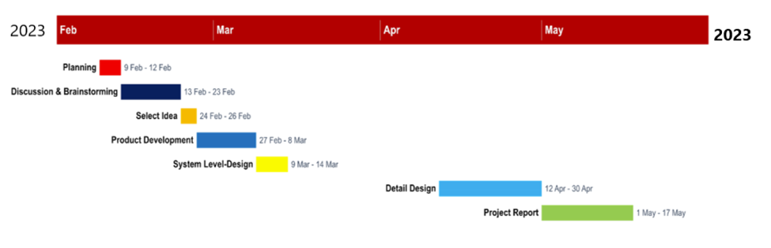
Figure 1 Gantt chart defining the project.

After that, a PERT analysis was conducted to visualize the project's critical path and identify potential bottlenecks. Because of this proactive approach, the team could anticipate delays and adjust their plan accordingly, as shown in Table 1.
Table 1: PERT table
Activity | Description | Estimated Time (days) | Predecessors | Optimistic Time (days) | Pessimistic Time (days)
A | Planning | 4 |  | 3 | 6
B | Discussion and brainstorming | 11 | A | 8 | 14
C | Select ideas | 2 | B | 1.5 | 3
D | Product development (high-level) | 8 | C | 6 | 10
E | System-level design | 5 | D | 3 | 7
F | Detail design | 12 | E | 8 | 18
G | Project report | 11 | F | 8 | 15

The critical path A-B-C-D-E-F-G, with a total duration of 54 days. Activities B and C are on a parallel path, allowing for concurrent exploration of ideas before committing to a specific direction. System-level design (E) precedes detail design (F) to ensure the overall device concept is viable before investing time in detail. Optimistic and pessimistic times are included for each activity to account for potential variations in efficiency and unexpected challenges. This analysis provides a range of possible project durations (43.5 to 73.5 days) and highlights areas where adjustments in resource allocation or time estimates can potentially shorten the critical path.

3.3) Cost Estimating

Figure 2 shows a broad view of the work breakdown structure (WBS) for the 'Falaj ' project, breaking it down into primary aspects and jobs with related cost estimates. The broad work breakdown structure enables a thorough grasp of each phase's financial requirements, assisting in effective budget planning and management. Bottom-up estimation guarantees that all project components, from initial research to final product launch, are budgeted for, reducing the chance of unplanned expenses.

Figure 2: WBS for the project

Project Phase | Duration | Cost Estimate (USD)
Planning | Feb 9 - Feb 12 | 500
Discussion & Brainstorming | Feb 13 - Feb 23 | 1,000
Select Idea | Feb 24 - Feb 26 | 500
Product Development | Feb 27 - Mar 8 | 20,000
System-Level Design | Mar 9 - Mar 14 | 7,500
Detail Design | Apr 12 - Apr 30 | 15,000
Project Report | May 1 - May 17 | 2,500
Total |  | 47,000

Table 2 shows the estimated costs related to establishing the project. Then, a different WBS was constructed to estimate the cost of manufacturing the product, as shown in the figure below.
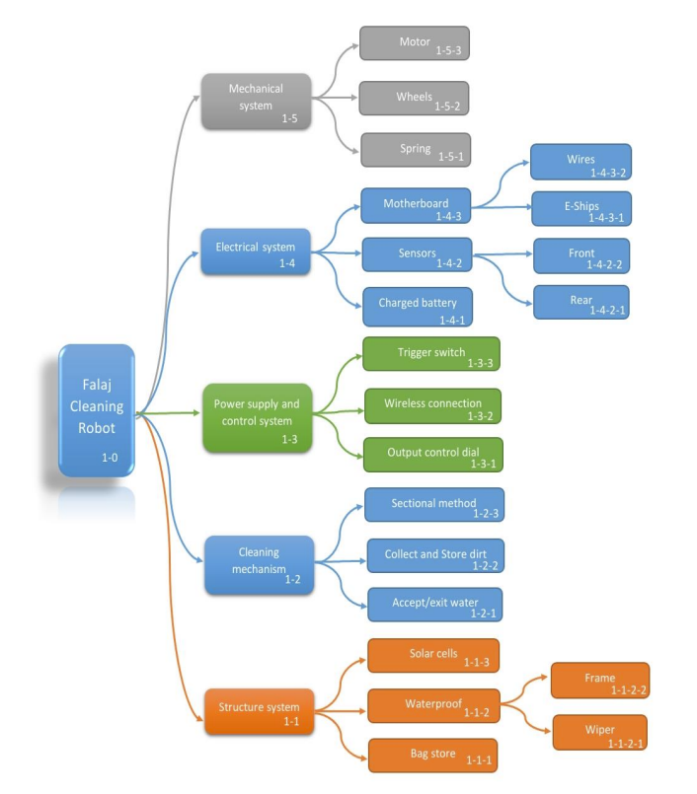

3.4) Risk Management

The team addressed the risks associated as follows

Phase 1 Identifying Risks: Invite team members, falaj users, and relevant specialists to brainstorm potential technical (design, material, compatibility), market (demand, competition), financial (financing, cost overruns), and operational (logistics, training, maintenance) concerns.
Document all identified hazards, including full explanations and likely consequences.
Assess the project's strengths (technical expertise, market knowledge), weaknesses (lack of experience with novel devices, untested market), opportunities (growing awareness of falaj maintenance needs, government support), and threats (competition from existing solutions, potential resistance from traditional communities).

Phase 2 Risk Assessment and Prioritization, A Likelihood and Impact Matrix was constructed below.
Risk | Likelihood | Impact on Project Goals (Cost, Schedule, Performance) | Mitigation Strategies
Technical Risks:
Device failure during testing | Medium (50%) | High: This may require significant redesign, delaying the project and increasing cost. | High: Rigorous prototype testing, thorough material selection, robust design.
Compatibility issues with existing Falaj systems | High (70%) | Medium: This may require adaptations and customization, impacting schedule and performance. | Medium: Flexible design solutions, user testing with different Falaj systems, and collaboration with local communities.
Manufacturing complexities or delays | Medium (50%) | Medium: This may lead to cost overruns and schedule delays. | Medium: Secure reliable suppliers, establish clear communication channels with manufacturers, and build contingency plans for delays.
Market Risks:
Low demand for the device | Medium (50%) | High: This may result in financial losses and project failure. | High: Thorough market research, effective marketing campaign, targeted outreach to falaj communities, consider alternative revenue models.
Competition from existing solutions | High (70%) | Medium: This may limit market share and profitability. | Medium: Develop a unique value proposition, highlight device advantages, and offer competitive pricing and user support.
Lack of awareness or acceptance among Falaj communities | High (70%) | Medium: This may delay adoption and require additional resources for training and support. | Medium: Community engagement, cultural sensitivity training for team members, user-friendly design and training materials, and partnerships with local authorities.
Financial Risks:
Difficulty securing funding | Medium (50%) | High: May stall project progress or require scaling back scope. | High: Develop a strong financial plan, secure diverse funding sources, and explore alternative financing options like grants or partnerships.
Cost overruns | Medium (50%) | Medium: This may impact profitability and require budget adjustments. | Medium: Effective cost estimation and tracking, implement cost-saving measures, secure contingency funding.
Unforeseen expenses | Medium (50%) | Low: Can be managed through contingency plans. | Low: Build contingency funds into the budget, regularly monitor project finances, and identify and address potential cost drivers early.
Operational Risks:
Logistical challenges in distributing and installing devices | Medium (50%) | Medium: This may delay implementation and increase costs. | Medium: Partner with local distributors, establish an efficient logistics network, and provide training and support for device installation and maintenance.
Lack of trained personnel for device maintenance | Medium (50%) | Medium: This may impact device performance and user satisfaction. | Medium: Develop training programs for falaj communities, provide ongoing support and maintenance services, and consider user-friendly design features.
Resistance to change from traditional communities | High (70%) | Medium: This may delay adoption and require additional effort for community engagement. | Medium: Build strong relationships with communities, address concerns openly, involve them in decision-making, and highlight the long-term benefits of the device.

Phase 3: Risk Response Strategies
- Risk Avoidance: Investigate alternate strategies or technology that eliminate high-impact, high-likelihood risks. Instead of designing a new device, consider collaborating with current Falaj maintenance providers or adapting existing solutions.
- Risk Mitigation: Take proactive steps to reduce the possibility or severity of identified risks. Do prototype testing and market research to confirm the device's effectiveness and user acceptance.
- Create adaptable design solutions for various Falaj systems and user preferences. To resolve concerns and assist adoption, establish close relationships with Falaj communities.
- Acceptance of Risk: Accept the risk after careful consideration and contingency planning for low-impact, low-likelihood risks.

3.5) Project Control

Abdulrahman's approach was more than merely dealing with fires. He established in the team a culture of open communication and proactive problem-solving. He gave team members the authority to identify problems and engage in problem-solving. For example, rising steel prices threatened to overrun the device fabrication budget. Abdulrahman renegotiated with different vendors quickly, getting a better deal without sacrificing quality. He also investigated using locally obtained products to cut down on transportation costs. Another example is Overtime Drain: long hours pushed payroll above budget due to complicated design adjustments. Abdulrahman attended brainstorming meetings with engineers, suggesting design simplification and workflow optimization possibilities. He also created flexible work schedules to avoid reliance on overtime. As for schedule problems, there was a Wish List Scope Creep where demands from passionate Falaj communities threatened to extend the project's timeline. Abdulrahman held open forums to understand better user desires, as well as to clarify the project scope and prioritize features based on impact and practicality. He also communicated clearly with stakeholders about the new timeline.

A bunch of changes occurred during the project:

- Request for Change No. 1: Replace imported steel with high-performance material supplied locally. The Reason was to lower costs and improve gadget performance. Abdulrahman provided the project steering committee with cost savings and performance gains. After analyzing technical reports and cost projections, the committee approved the amendment, with a slight budget increase to pay for additional testing.
- Request for Change No. 2: Modification: Simplify device design for interoperability with various Falaj systems. The reason was to ensure broader acceptance and to address user concerns. Abdulrahman facilitated a team meeting to review user input and technical feasibility. The team provided several design alternatives and discussed how they may affect the project duration and budget. After extensive discussion and stakeholder consultation, the steering committee approved the design changes with a revised launch date.

3.6) Evaluation, Reporting, and Termination

Many types of meetings were held:
- Weekly Team Meetings: To track progress, identify obstacles, and discuss updates, we hold weekly team meetings. This ensured collaboration and quick problem resolution.
- Bi-weekly Stakeholder Meetings: Abdulrahman met with key engineers and Falaj community leaders to discuss project progress, answer user complaints, and assure stakeholder alignment.
- Monthly Steering Committee Meetings: Attended by top management and funding organizations, these high-level meetings examined project financials, technical milestones, and overall progress. They gave important direction and aided in critical decision-making.

Transparency and accountability were critical throughout the Falaj device project. The steering committee documented and assessed the changes, while Abdulrahman kept stakeholders up to date with full reports outlining progress, accomplishments, and potential hazards. This ended in a team-prepared final summary report describing the project's progress, its influence on falaj maintenance, and significant lessons gained.

As the Falaj device approached completion, the project moved into a final phase focused on installation, training, and user support, assuring a smooth transfer to the falaj communities. Minor contract revisions were discussed with the customer to handle unexpected demands, ensuring fairness and mutual benefit. Finally, Abdulrahman's thorough examination of deliverables, finances, and outstanding tasks effectively concluded the project.

4)Conclusion

The Falaj cleaning device was brought to life by AAH Innovations' careful planning, proactive risk reduction, and clear communication, offering a valued product and improving their future projects. This project demonstrated the effectiveness of strong task breakdown structures, time-cost tradeoffs, proactive risk management, and continuous performance monitoring. Furthermore, project agility and impact were ensured via a systematic change management procedure and documented knowledge transfer.

